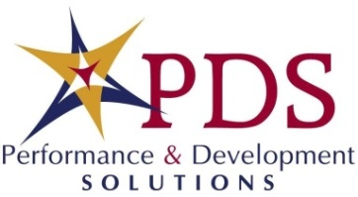
Advanced Talent Development Certificate (ATDC)
Employee Name: | Certificate Start Date:
Department: | Certificate Completion Date:

Date Completed: |  | Employee Initial: |  |  | Course:
 |  |  |  |  | Advanced Principles of Communication – Part 1: Authenticity
 |  |  |  |  | Advanced Principles of Communication – Part 2: Coaching
 |  |  |  |  | Creating a Violence Free Workplace
 |  |  |  |  | Enhancing Team Membership
 |  |  |  |  | Getting Things Done
 |  |  |  |  | Managing Stress & Workplace Accountability
 |  |  |  |  | The Role of the Lead Worker
 |  |  |  |  | Strategies for Achieving Work/Life Balance
 |  |  |  |  | Thriving on Change

Employee Signature
Supervisor Signature
Training Liaison Signature
Performance & Development Signature

