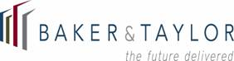

1453 North 250 East • Orem, UT 84057
801-228-7032 • jan.anderson@baker-taylor.com

9 November 2016

Steve Cox
State Library of Iowa
12th and Grand Avenue
Des Moines, IA 50319

Please find below renewal pricing for State Library of Iowa, for Bibliostat Collect and Bibliostat Connect, for renewal in February 2017, and also for adding an additional third survey:

Bibliostat Collect
$8,300

Bibliostat Connect
$24,860

Both subscriptions are for statewide access to all public library and state library staff.

Sincerely,

Jan Anderson
Bibliostat Sales Manager

