03/11/2015

To Whom It May Concern,

CovertTrack Group, Inc. is the sole provider to of the Stealth III GPS tracker. Coverttrack Group, Inc. is the sole provider of service on tracking units sold by our company. The internal programming would not work on another mapping system as the device is programmed to work with our mapping site. Coverttrack Group, Inc. and its tracking service (coverttrack.com) are exclusive to the devices that we manufacture and program. This application will only work on our mapping site at Coverttrack.com.

Sincerely,
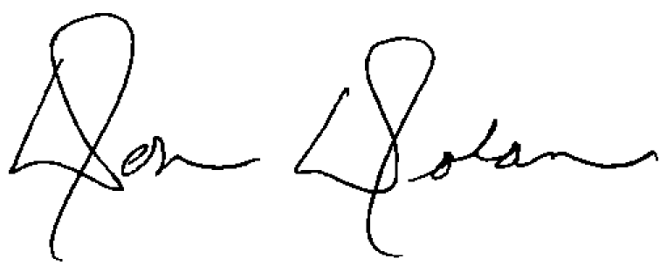

Don Dolan
Director of Sales and Business Development

CovertTrack Group, Inc.
8361 E. Gelding Drive
Scottsdale, AZ 85260
Direct (480) 699-7281
Office (480) 661-1916
Fax (480) 451-5421
mailto:Don@coverttrack.com

