Congratulations on your decision to retire! We know that retirement can feel like a complicated process. To ensure that your retirement with the State of Iowa is successful, please complete the following steps.

The Retiree Website is a great resource that provides an overview of the retirement process and has helpful information that may answer many of your retirement questions.

Step 1: Written Notice
Before the retirement process can start, a written notice is required stating your plans to retire. This written notice needs to be submitted to your supervisor and sent to me as your HRA as well.

Step 2: IPERS
You must contact IPERS at 515-281-0020 to receive your IPERS packet. Included in the packet is the Employment Verification form. Please send this to me as I am required to complete this section of the paperwork and send it back to you prior to you returning the completed packet to IPERS.

Step 3: Insurance
If you currently waive both Medical and Dental coverage, you are not eligible to enroll in Retiree Medical and Dental coverage. Please skip to Step 4.
If you currently have Medical and/or Dental coverage as a State Employee, you are eligible to continue in the State’s Retiree Insurance Program.
Your current insurance benefits will run through the end of the month in which you retire.
Below are links to the premium amounts for the available plans.
Retiree Health and Dental Premiums

Please complete the following required applications and return them to me with your selections to continue the retirement process.

*If you currently have a Dependent who is Medicare eligible, please reach out to the Retiree Specialist at stateretirees@iowa.gov or call 515-281-6124.

- Application for the Retired/Disabled Health and Dental Insurance Group : this form is required whether you choose to continue or waive health and/or dental coverage.

- Wellmark Medical Plans
  - Required if continuing medical coverage: Wellmark Health Application for Retirees.

- Delta Dental Plan
  - Required if continuing Dental coverage: Delta Dental Insurance Application
  - Optional for automatic withdrawal of your premium from your bank account: Delta Dental's Authorization for Automatic Bank Account Withdrawal.

Step 4: Optional Retirement Investors’ Club (RIC)
If you are currently contributing to our Retirement Investors' Club deferred compensation program and anticipate a lump sum as part of your Vacation and/or Sick payout, you can choose to have some or all of those funds deposited into your RIC account. Complete the Special Deduction Request Form and send it directly to the RIC Team. Please do not include this form with the other forms that you return to me. To contact the Retirement Investors' Club Team, email ric@iowa.gov or call 515-281-8677.

If you are not currently enrolled in RIC, you may still have the opportunity to defer your Vacation and/or Sick payout. You can find information about enrollment on the RIC website under Enrollment. If you have any questions, please reach out to the RIC Team no later than two weeks before your last day of work.

Step 5: Optional Tax Elections
Alternatively, you may choose to receive a lump sum cash payout of any remaining Vacation or Sick time. If so, you may wish to adjust your W-4 Federal /State withholdings for your final paycheck. You may update these in Workday. For assistance, you may reference the Payroll Smart guides here: Change Federal Withholding Elections and Change State Withholding Elections.

Step 6: Final Payout Estimates
In order to receive a final payout, you must have submitted and have your IPERS packet approved by IPERS to be processed as a Retirement in Workday. Sick hours are paid up to a maximum of $2000. Below is a screenshot of what your Vacation and Sick payouts may look like as estimated through your last day. Please keep in mind that this estimate can change based on any Vacation and/or Sick time you use between now and your last day.

Note: To view your Vacation and Sick leave balances, select Time from your Workday Homepage. Under View, select Time Off Balance.

Replace this example with the Retiree’s information (delete this comment before sending)
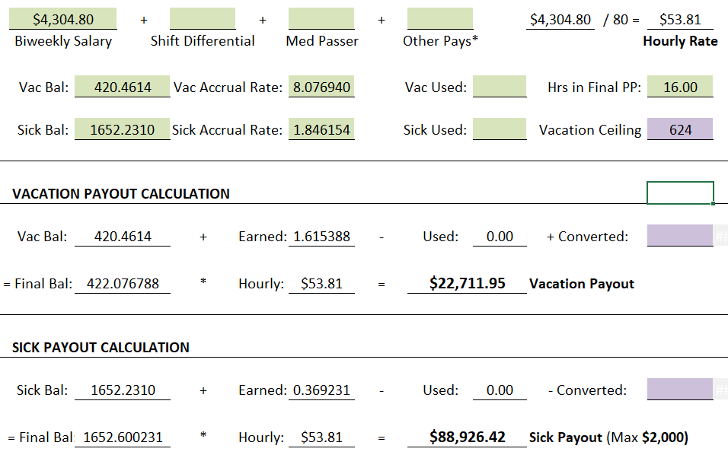

Step 7: Life Insurance Coverage
If you have questions about continuing your Life Insurance coverage, your eligibility, or the status of any request you have submitted, please contact The Standard at 844-450-5547. Port/Convert FAQ

Step 8: Health Flexible Spending Account (FSA)
If you have a Health Flexible Spending Account and you are interested in prepaying your Health FSA pre-tax contributions with your last check, you may complete and submit the Health FSA Prepayment Form. If you have questions, contact the Flex Plan Administrator, Jennifer Sandusky, at 515-281-0569 or by email at jennifer.sandusky@iowa.gov.

Step 9: Upon Medicare Eligibility
State Health Insurance Plans and Medicare
You can continue coverage with a State of Iowa health insurance plan when you become eligible for Medicare. If you do, it will continue as a Medicare carve-out policy with the same benefits and will pay secondary to Medicare Parts A and B. Benefits offered to Medicare-eligible retirees are the same as the benefit plan offered prior to becoming Medicare-eligible. If you choose to continue in one of the state-sponsored health plans, you must notify Wellmark of your enrollment in both Parts A and B of Medicare. Medicare becomes the primary payer on your claims and the state health plan is the secondary payer.

*If you currently have a Dependent who is Medicare eligible, please reach out to the Retiree Specialist at stateretirees@iowa.gov or call 515-281-6124.

Step 10: Optional Retirement Sessions
Do you want to know even more helpful information about retirement? IPERS has some great resources too! Once a month IPERS holds two classes for employees who are planning on retiring within the next five years. Please click on the links to learn more about each class and how to register.

- IPERS Presents Ready, Set, Retire on Zoom
- Creating a Secure Retirement

We want your retirement to be as seamless as possible, and working together can help resolve any issues before they arise. In order to process your retirement in a timely manner and to avoid any delays, please send me all the required forms completed as soon as possible. If you have any questions, please let me know.

