Certified Public Manager Program Application

Part A: To Be Completed By Applicant

Preferred CPM Cohort (Start Date or Cohort Number):

Employee Name:
 | (Last) |  | (First) |  | (Initial)

Title: |  | Organization:

Business Address:

Home Address:

Email Address:

Phone Number:

Please check the category below that most accurately describes your current position:

 | Senior Manager |  | Middle Manager |  | Supervisor |  | Employee

Please check the category below that most accurately describes your level of education completed:
 | High School |  | Associate |  | Baccalaureate |  | Graduate

Total Years in Government:

Please briefly describe your management and leadership experience: (Attach an additional sheet if desired)

Please attach the following with this application:
- Signed letter of intent to participate fully and complete all requirements (Part C)
- Letter of recommendation from your supervisor or manager

Applicant’s Signature: |  |  | Date:
Submit completed applications and attachments to:
Accommodation Request: Please indicate if you have any special needs that we can address to make your participation more enjoyable.
Please allow eight weeks notification.

Braille Sign Language Interpretation Large Print Other:

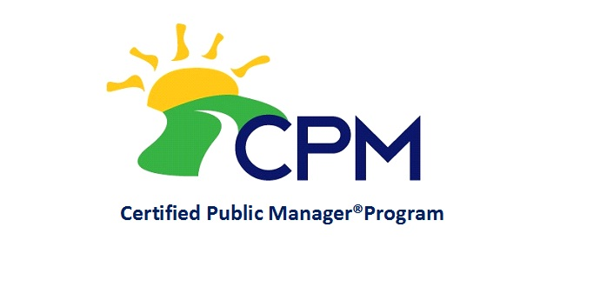
Performance & Development Solutions
Department of Administrative Services
Human Resources Enterprise
Hoover State Office Building, Level A
1305 East Walnut
Des Moines, IA 50319
Certified Public Manager Program Application

Part B: To Be Completed By Employer

Courses will be held over 17 months in Des Moines, generally two consecutive days each month. The curriculum consists of 300 hours of professional training. The cost of the program is $3,500.

BILLING INFORMATION:

Organization:

Billing Contact: |  | Contact Phone:

Address:

City: |  | State: |  | Zip:

STATE AGENCIES ONLY:
Accounting Line:
 | (Fund) |  | (Agency) |  | (Org)

BILLING PREFERENCES (please check one):
Please bill agency/organization a one-time fee of $3,500
Please bill agency/organization a monthly fee of $250 for 14 months
Special billing instructions:

This nomination for has been made without preference to race, color, national
(Employee Name-Printed)
origin, sex, age, disability, creed, or religion. This applicant will be permitted to participate in and complete all requirements

of the Certified Public Manager Program.

Name of Supervisor:

Title: |  | Phone:

Supervisor Signature:

Organization Director/Appointing Authority Signature:

For more information about the CPM program, visit our website: https://das.iowa.gov/human-resources/training-and-development/certified-public-manager

Rev. 12/06
Certified Public Manager Program Application

Letter of Intent

Part C: To Be Completed By Applicant

Performance & Development Solutions
Department of Administrative Services
Human Resources Enterprise
Hoover State Office Building, Level A
1305 East Walnut
Des Moines, IA 50319

CPM Program Coordinator:

This letter expresses my intent to participate fully and complete all requirements of the Certified Public Manager Program. I will commit to attend and participate in all classes throughout the seventeen-month curriculum. Additionally, I will commit to applying the program’s principles and the professional knowledge gained to my current working environment.

Sincerely,

(Participant’s Signature) (Date)

