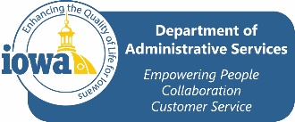
SPOC Vacation to Sick Leave Conversion

Name |  | Department

I am exercising the option to convert my accrued vacation to sick leave according to the Collective Bargaining Agreement between State of Iowa and State Police Officers Council (Article IX, Section 6.A.5).
Fiscal Year Conversion
- I understand that I can convert any amount of vacation leave up to 50 hours to sick leave.
- I understand that the conversion rate is two hours of vacation for one hour of sick leave.
- I understand that this action may be taken only once during each fiscal year, even if I do not convert the entire 50 hours for which I am eligible.
I elect the number of vacation hours to be converted:
NOTE: This form maybe submitted by the employee at any time during the fiscal year. The action will be taken as soon as possible after receipt of the completed form by the Human Resources Associate.

Retirement Conversion
- I am age 50 or older and I am retiring.
- I understand that I can convert ALL vacation hours into sick leave.
- I understand that I can convert any or all holiday compensatory time
- I understand that I can convert up to 100 hours of compensatory time
- I understand this action may be taken only once at the time of retirement.
- Conversion rate will be one hour for one hour
I elect the number of vacation hours to be converted:

Please sign and retain a copy of this form for your records.

Employee Signature Date
Return this form to your department’s Human Resources Associate.
FOR HRA USE ONLY

Date Completed From Received: _______________________
Pay Period Processed: __________________

